
COMPUTER ENGINEERING
OOPM ODD SEM 2021-22/EXPERIMENT 4 NAME:- GAURAV AMARNANI (D7A, 67)

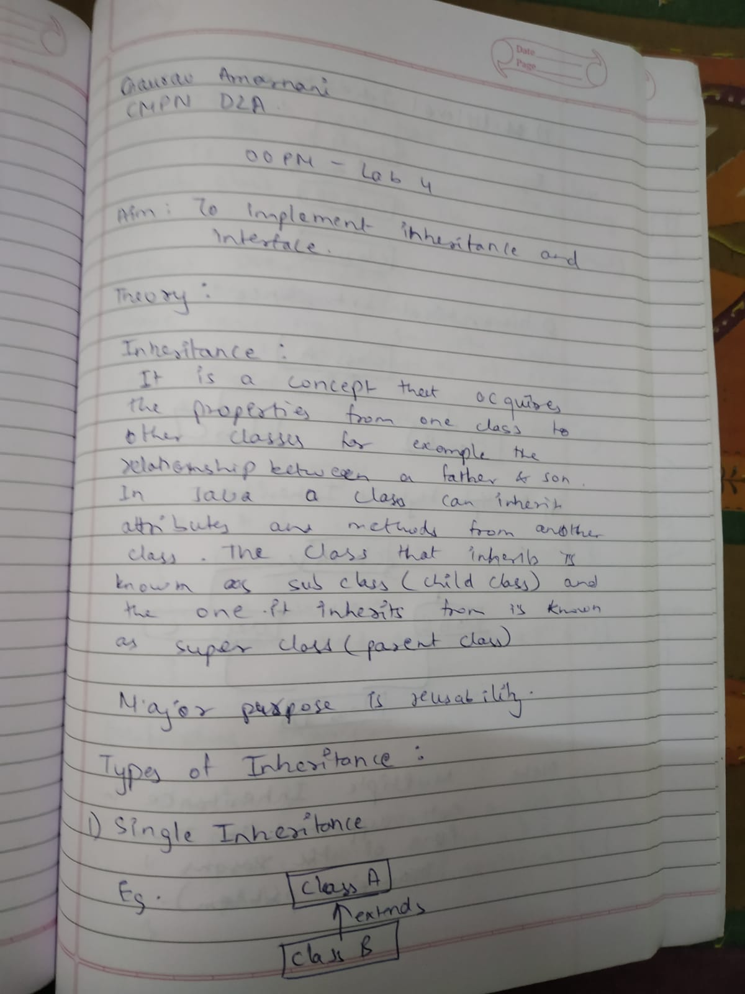
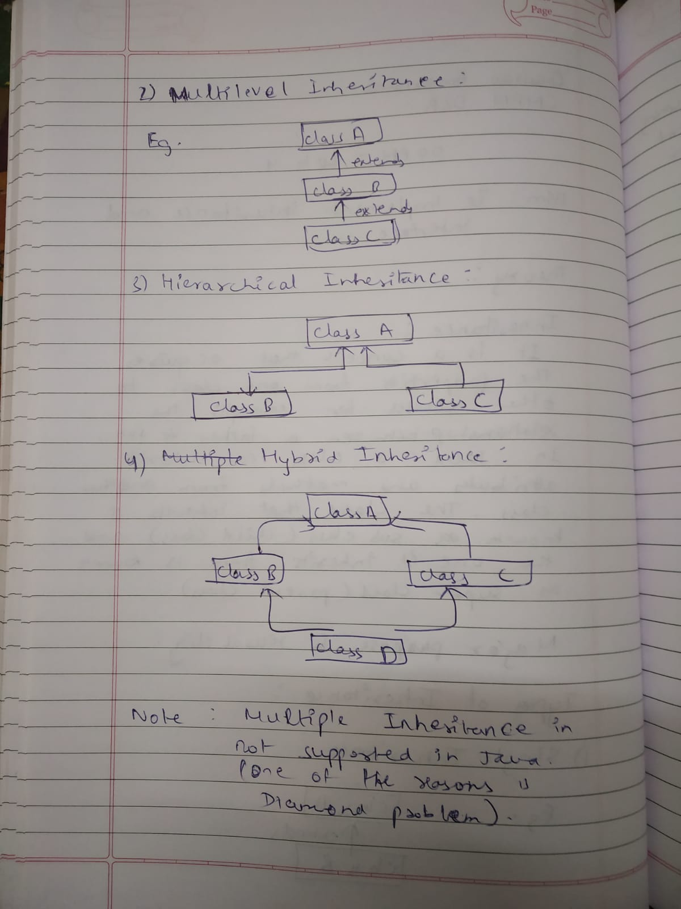
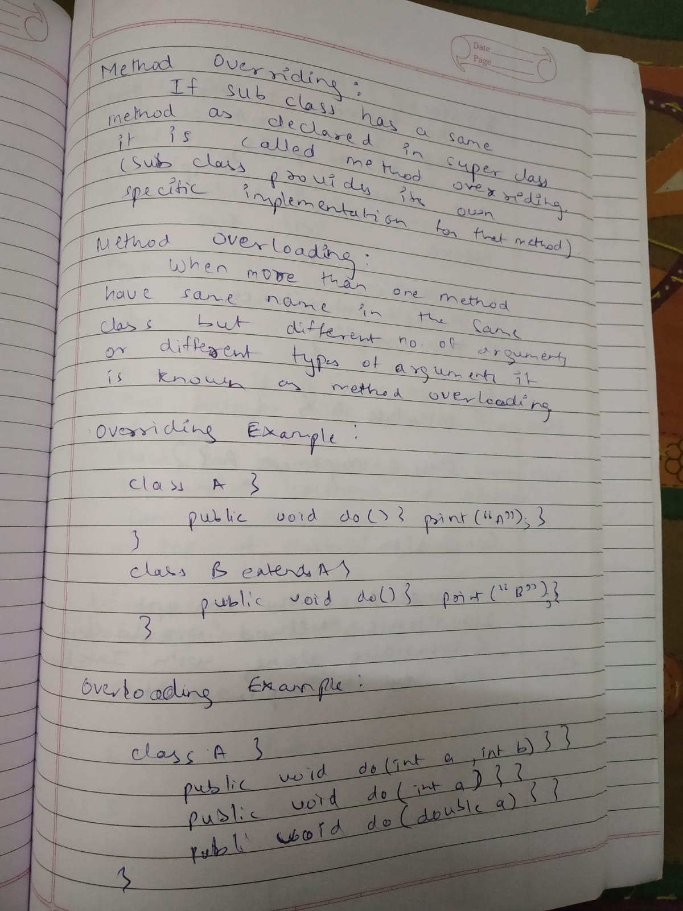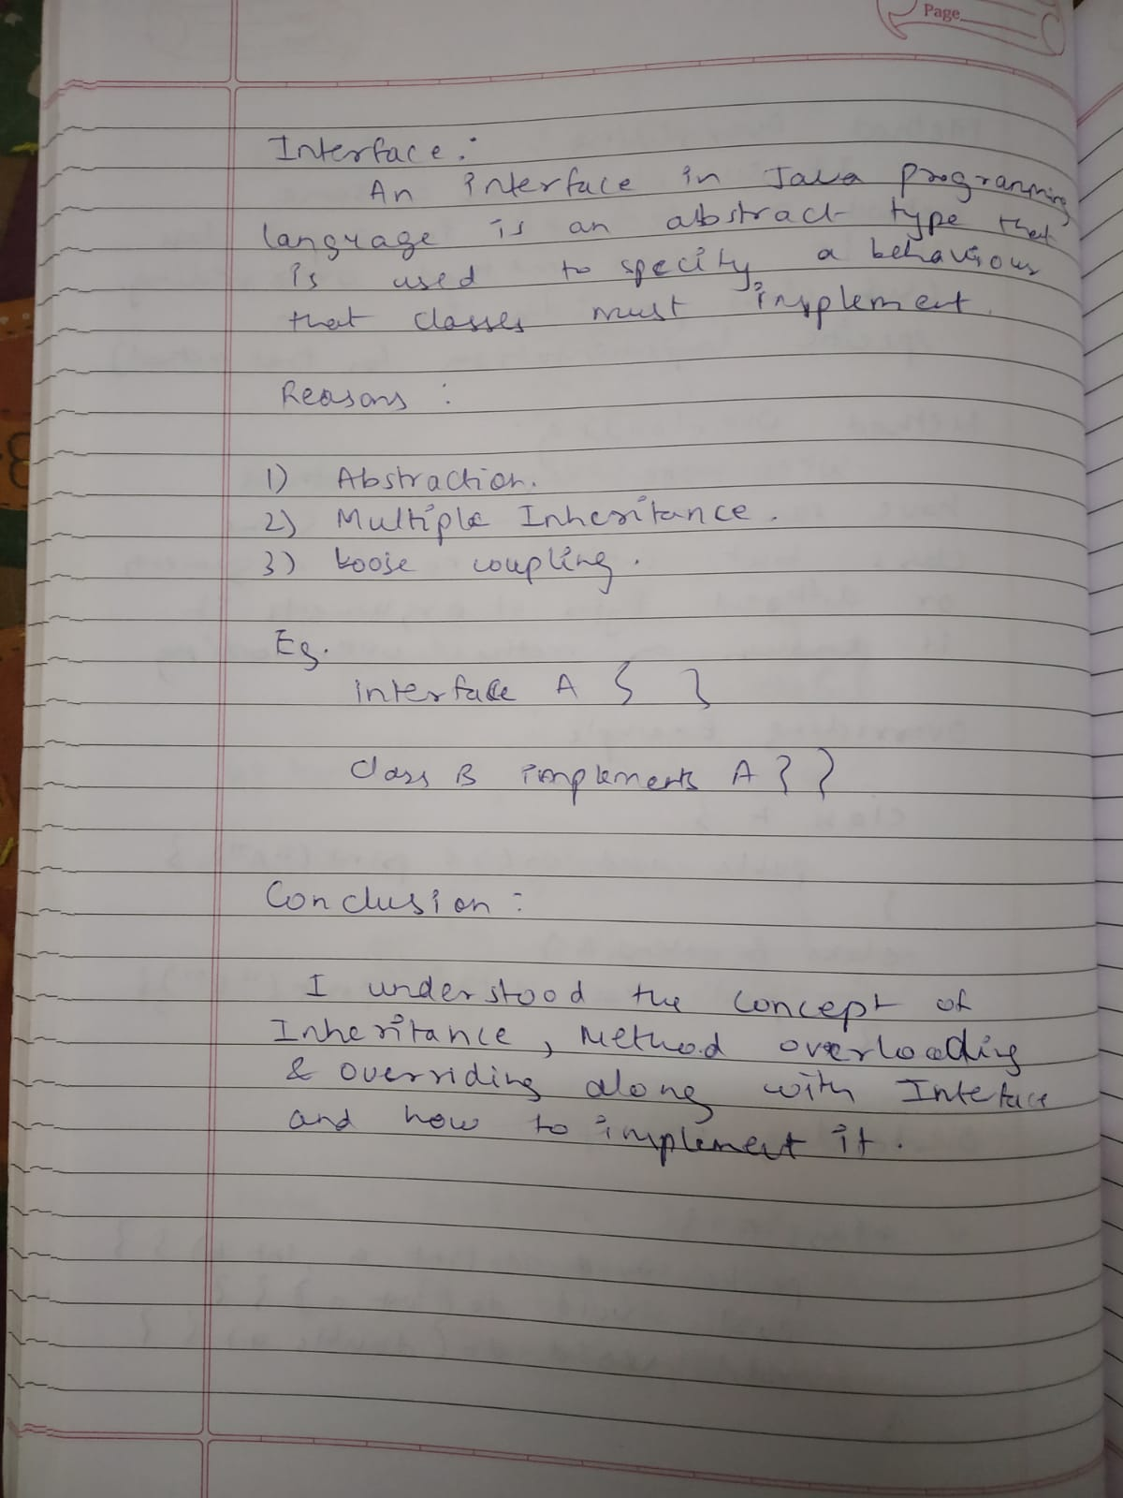

Program 1

class Animal {
String name;
public void eat() {
System.out.println("I can bark");
}
}

class Dog extends Animal {
public void display() {
System.out.println("My name is " + name);
}
}

class exp_4_1 {
public static void main(String[] args) {
Dog labrador = new Dog();
labrador.name = "shero";
labrador.display();
labrador.eat();
}
}

Output:
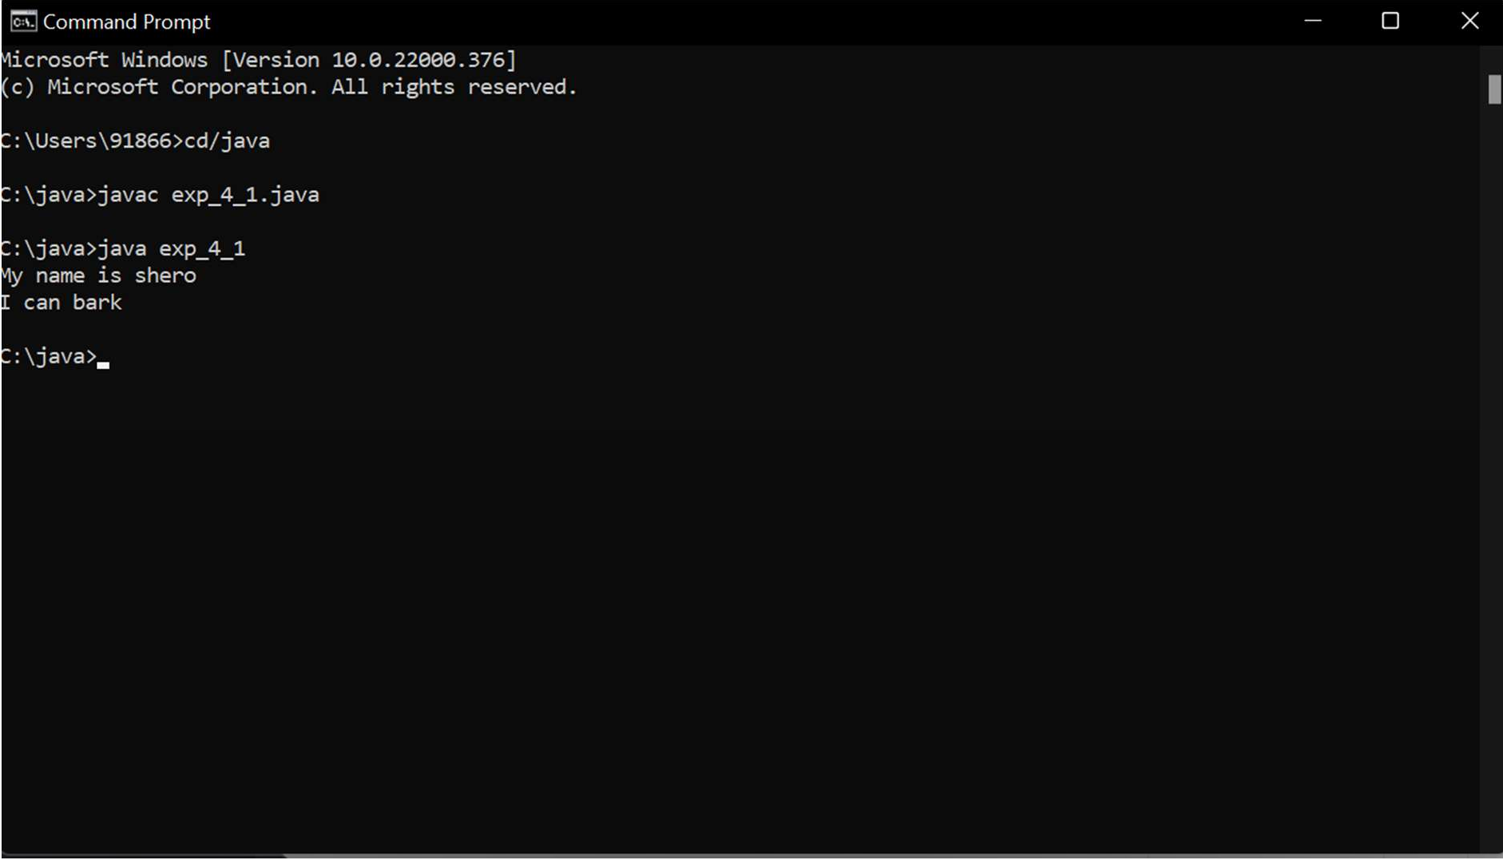

Program 2

class Shape {
public void display() {
System.out.println("display");
}
}

class Rectangle extends Shape {
public void area() {
System.out.println("area");
}
}

class Cube extends Rectangle {
public void volume() {
System.out.println("volume");
}
}

public class exp_4_2 {
public static void main(String[] arguments) {
Cube cube = new Cube();
cube.display();
cube.area();
cube.volume();
}
}

Output:

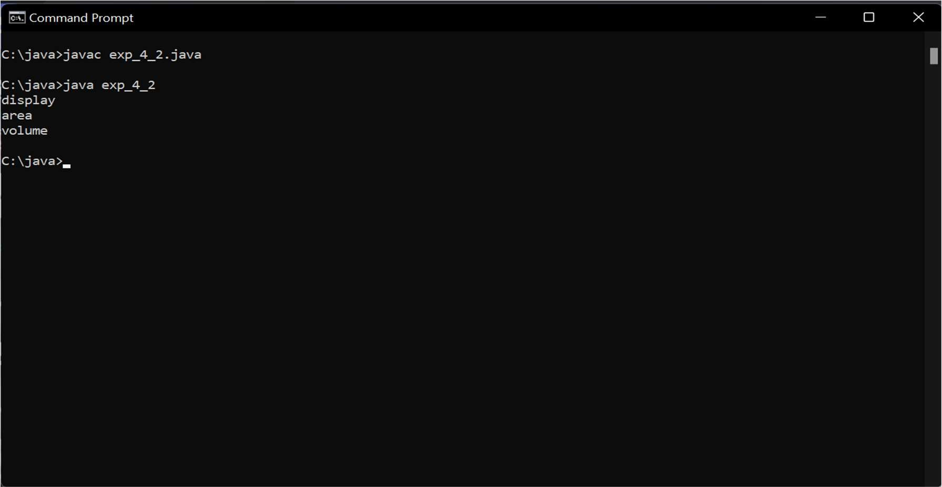
Program 3

class Animal {
void eat(){
System.out.println("sleeping...");
}
}

class Dog extends Animal {
void bark(){
System.out.println("eating...");
}
}

class Cat extends Animal {
void meow(){
System.out.println("meowing...");
}
}

public class exp_4_3 {
public static void main(String args[]){
Cat c=new Cat();
c.meow();
c.eat();
}
}

Output:

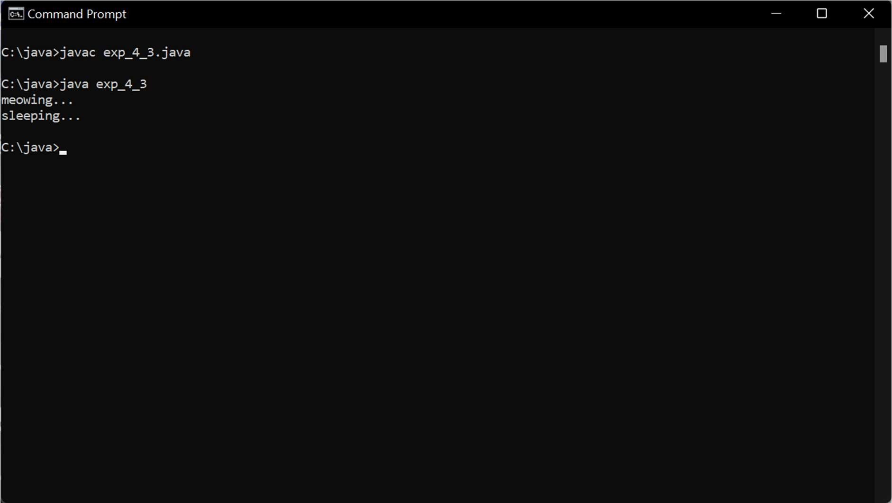

Program 4

interface Genre {
default void show() {
System.out.println("Student can choose following genre in Movies:");
System.out.println("1.western 2.Horror 3.Comedy 4.Action 5.Drama 6.sci-fi");
}
}

interface Game {
default void show() {
System.out.println("Student can choose following Game Genre:");
System.out.println("1.Shooting 2.Roleplay 3.Simulation 4.Puzzle 5.Adventure ");
}
}

class exp_4_4 implements Genre, Game {
public void show(){
Genre.super.show();
Game.super.show();
}

public static void main(String args[]){
exp_4_4 e = new exp_4_4();
e.show();
}
}

Output:

